**DDD**

Adapted by Neilor Tonin, URI https://urionlinejudge.r.worldssl.net/gallery/images/flags/br.gif Brazil

**Timelimit: 1**

Read an integer number that is the code number for phone dialing. Then, print the destination according to the following table:

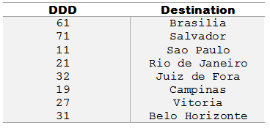

If the input number isn’t found in the above table, the output must be:  
DDD nao cadastrado  
That means “DDD not found” in Portuguese language.

**Input**

The input consists in a unique integer number.

**Output**

Print the city name corresponding to the input DDD. Print *DDD nao cadastrado*if doesn't exist corresponding DDD to the typed number.

| **Sample Inputs** | **Sample Outputs** |
| --- | --- |
| 11 | Sao Paulo |

|  |  |
| --- | --- |
| 33 | DDD nao cadastrado |

<https://www.urionlinejudge.com.br/judge/es/problems/view/1050>

#include <iostream>

#include <stdio.h>

using namespace std;

int main(){

int n;

scanf("%d",&n);

if(n == 61){

printf("Brasilia");

}else if(n == 71){

printf("Salvador");

}else if(n == 11){

printf("Sao Paulo");

}else if(n == 21){

printf("Rio de Janeiro");

}else if(n == 32){

printf("Juiz de Fora");

}else if(n == 19){

printf("Campinas");

}else if(n==27){

printf("Vitoria");

}else if(n == 31){

printf("Belo Horizonte");

}else{

printf("DDD nao cadastrado");

}

printf("\n");

return 0;

}